URL: <http://zero.webappsecurity.com>

Xpath & CSS:

1. Question icon - Sign in > Login > Account Summary > Pay Bills > Pay Saved Payee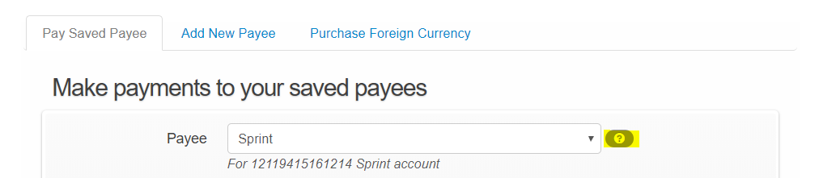
2. Info text - Sign in > Login > Account Summary > Pay Bills > Pay Saved Payee

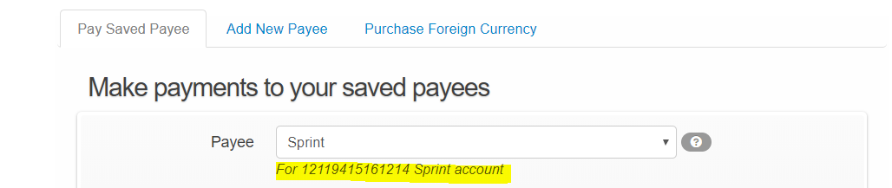

1. Today’s Sell Rate - Sign in > Login > Account Summary > Pay Bills > Purchase Foreign Currency

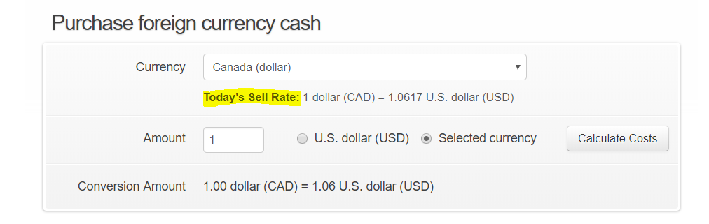

1. Selected currency - Sign in > Login > Account Summary > Pay Bills > Purchase Foreign Currency

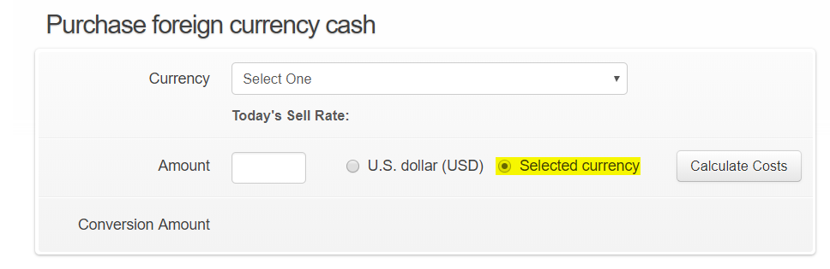

1. Resultant Conversion Amount- Sign in > Login > Account Summary > Pay Bills > Purchase Foreign Currency

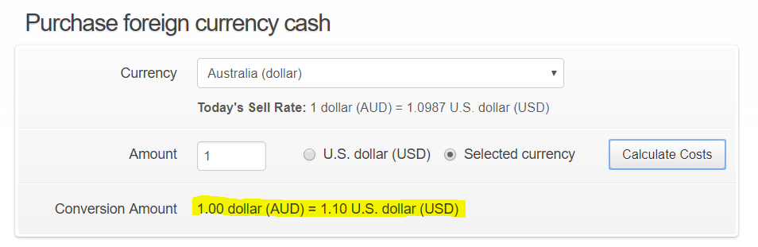

1. Third listing year in Saving account - Sign in > Login > Account Summary > Online Statements > Statement & Document = ‘Savings’

Note: Check for unselected year

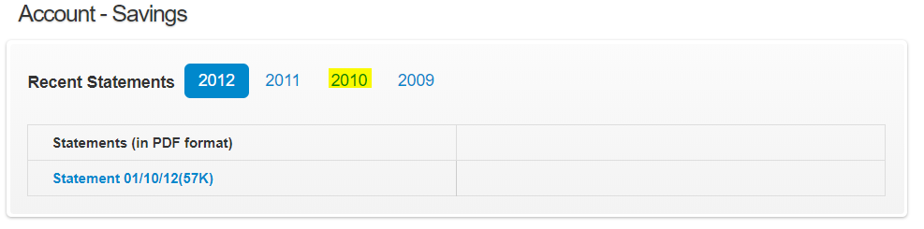

1. Selected year in Saving account - Sign in > Login > Account Summary > Online Statements > Statement & Document = ‘Savings’

Note: Check for selected year

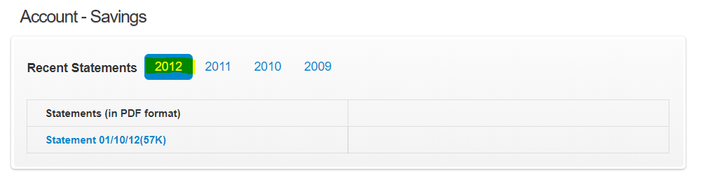

1. Second statement - Sign in > Login > Account Summary > Online Statements > Statement & Document = ‘Brokerage’

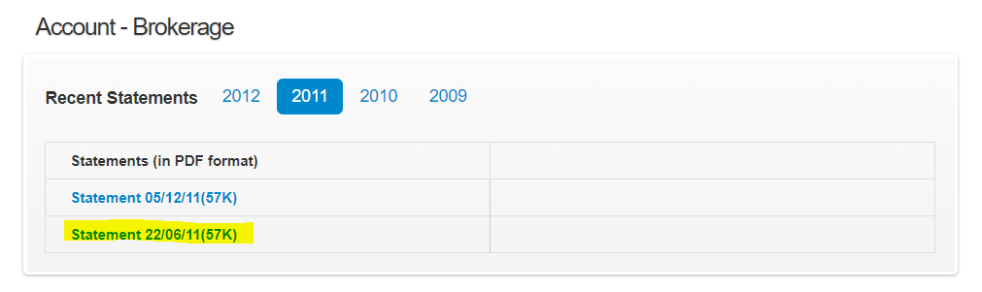

1. My Profile - Sign in > Login > Account Summary > Username > My Profile

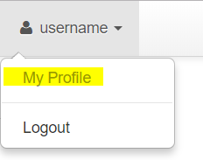

1. Settings - Sign in > Login > Account Summary > Settings

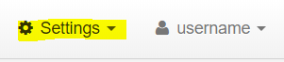

1. What’s Left - Settings - Sign in > Login > Account Summary > My Money Map > What’s Left

